Tasks on Ansible – 01
1) Watch ansible-02 video and write down notes.

Completed watching video and prepared notes.

2) Install httpd using ansible playbook, use handlers,notifiers.

Playbook used:
---
- hosts: all
become: yes

tasks:
- name: Install Apache
apt:
name: apache2
state: latest
update_cache: yes

- name: Copy index.html to web server
copy:
src: index.html
dest: /var/www/html/index.html
notify: restart apache2

handlers:
- name: restart apache2
service:
name: apache2
state: restarted

Create separate directories playbooks.

mkdir playbooks

create a apache.yml file to enter playbook modules.

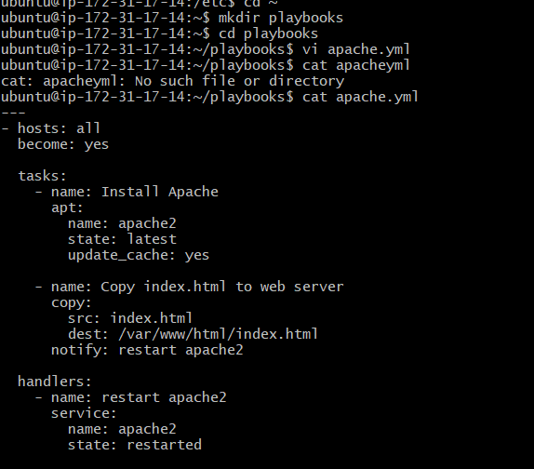

ansible-playbook apache.yml --syntax-check – To check the syntax.

ansible-playbook apache.yml –check – To dry run and know the output.

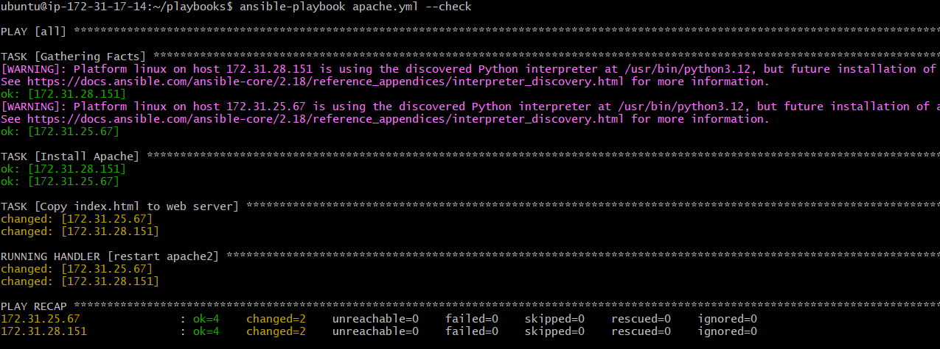

ansible-playbook apache.yml – To run/execute the playbook.
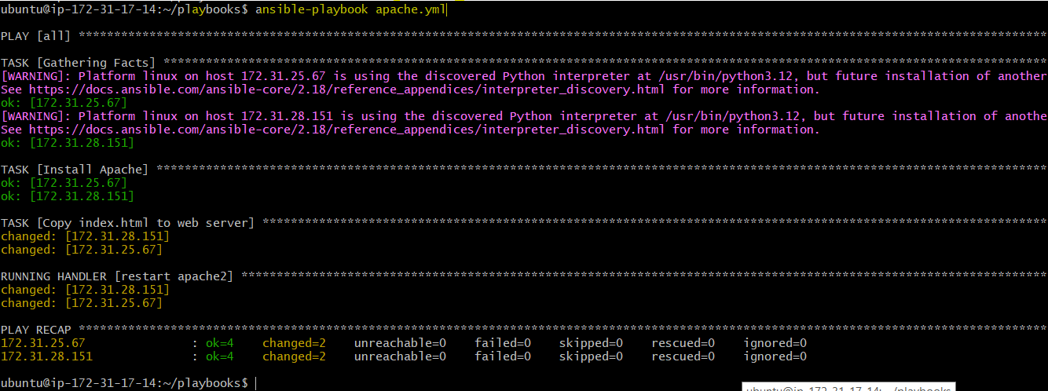

Lets check output:
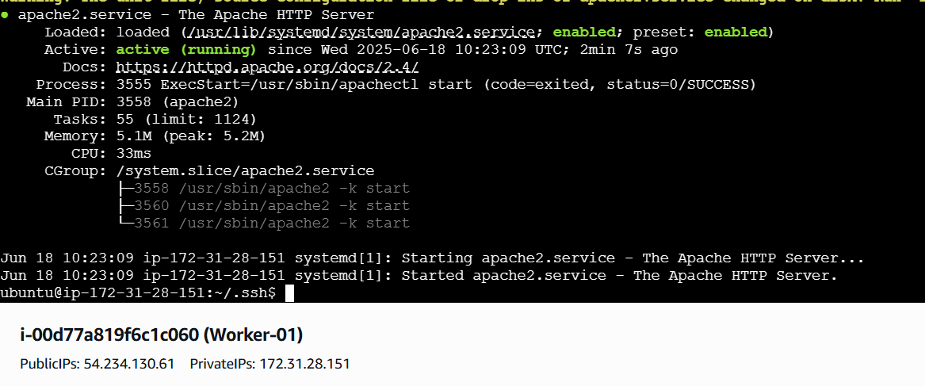
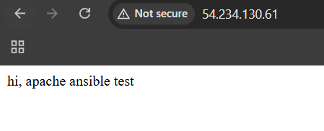
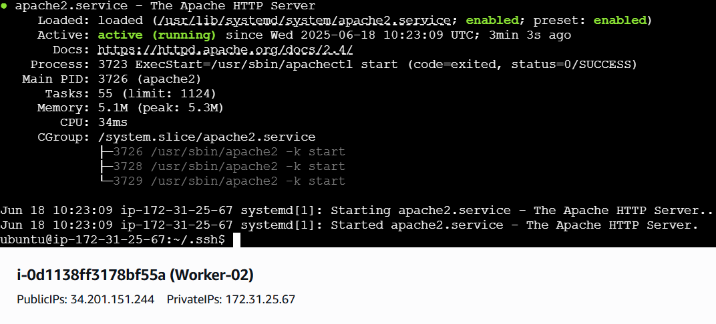
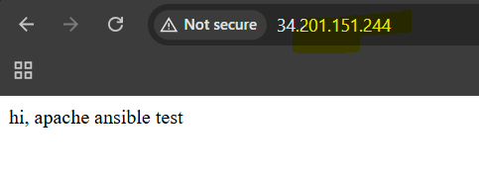

Let us make changes in index.html and re-run the job and check the output.
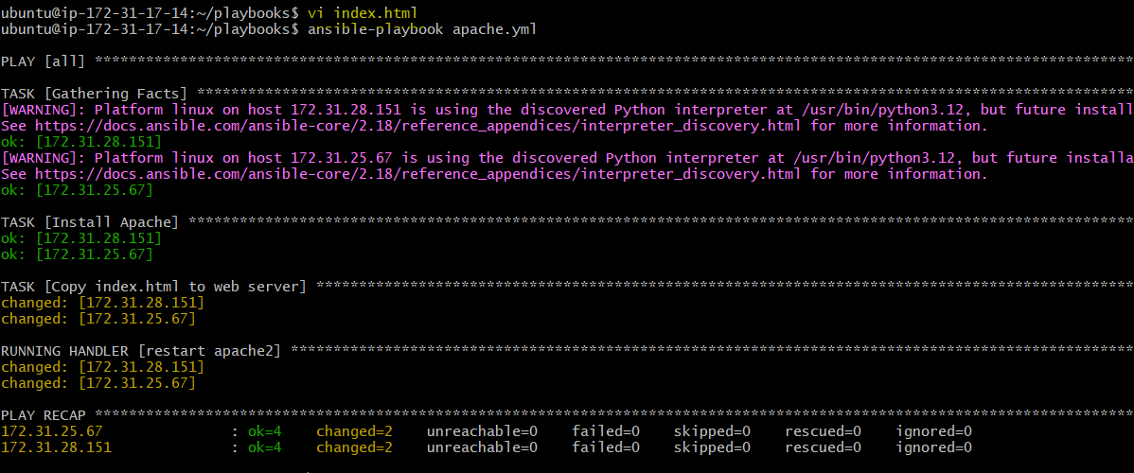

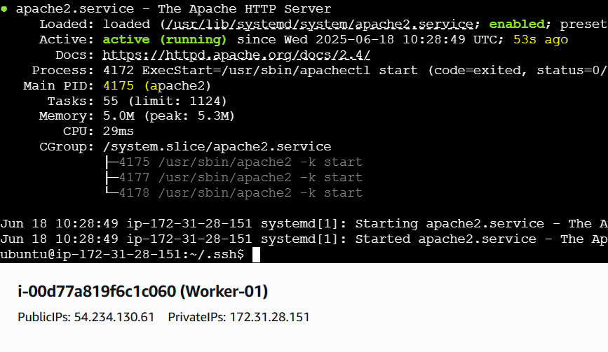
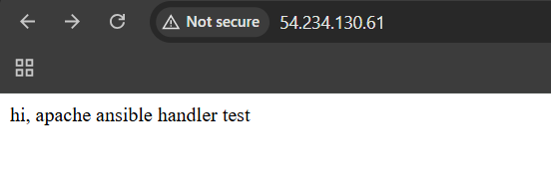

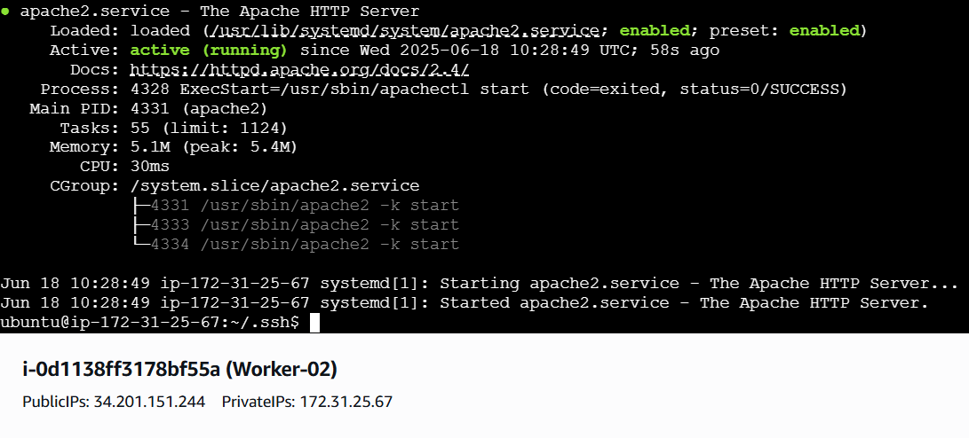
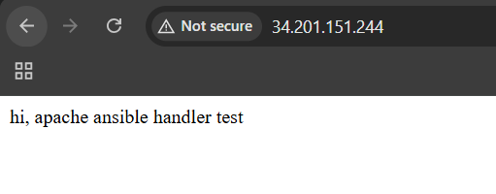

We can observe that, PID and Uptime is changed for the apache after making changes in index.html and re-run the template.

3) Write a ansible playbook to install apache tomcat.

Playbook used:
---
- name: Minimal Apache Tomcat Installation on Ubuntu
hosts: all
become: yes
tasks:
- name: Install Java
apt:
name: default-jdk
state: present
update_cache: yes

- name: Download Tomcat 9.0.106
get_url:
url: https://dlcdn.apache.org/tomcat/tomcat-9/v9.0.106/bin/apache-tomcat-9.0.106.tar.gz
dest: /tmp/apache-tomcat-9.0.106.tar.gz

- name: Extract Tomcat
unarchive:
src: /tmp/apache-tomcat-9.0.106.tar.gz
dest: /opt/
remote_src: yes

- name: Start Tomcat
shell: nohup /opt/apache-tomcat-9.0.106/bin/startup.sh &

create a tomcat.yml file to enter playbook modules.
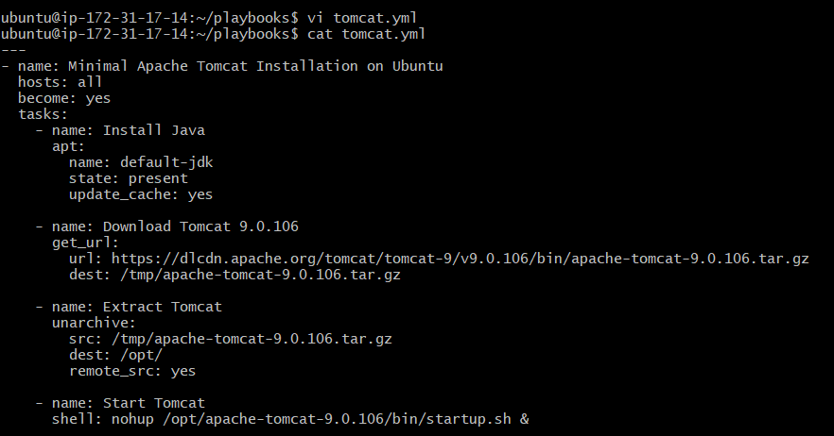
ansible-playbook tomcat.yml --syntax-check – To check the syntax.

ansible-playbook tomcat.yml --check – To dry run and know the output.
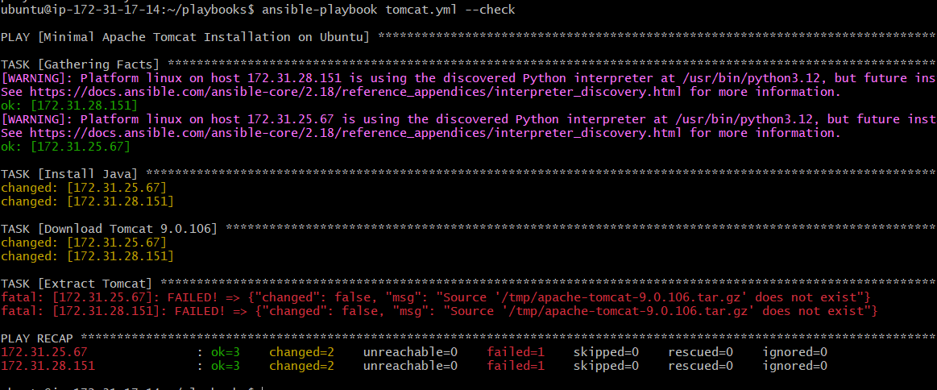

Error is valid before execution. This is after execution of playbook.

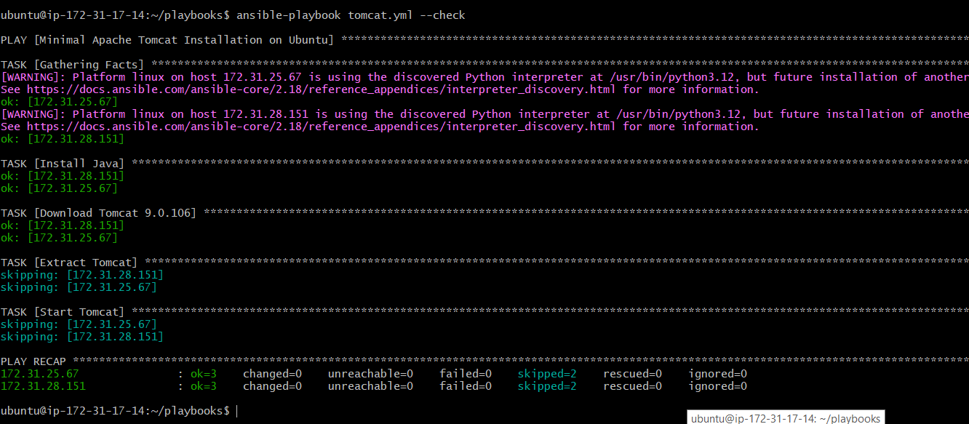

ansible-playbook tomcat.yml – To run/execute the playbook.
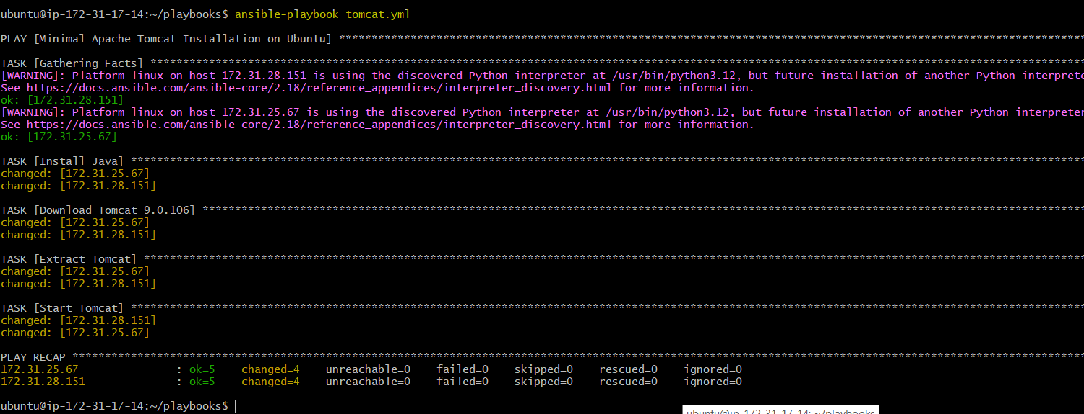

Lets, check output:
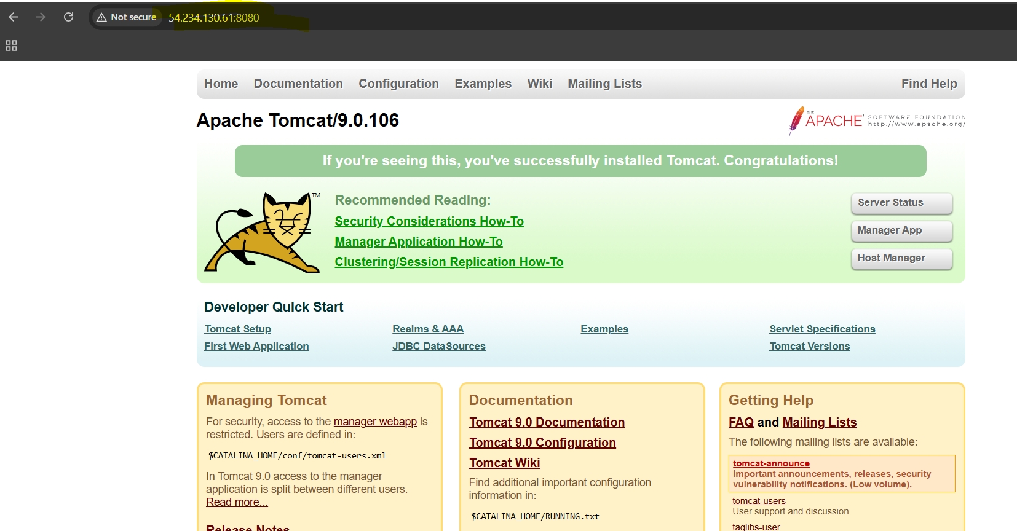
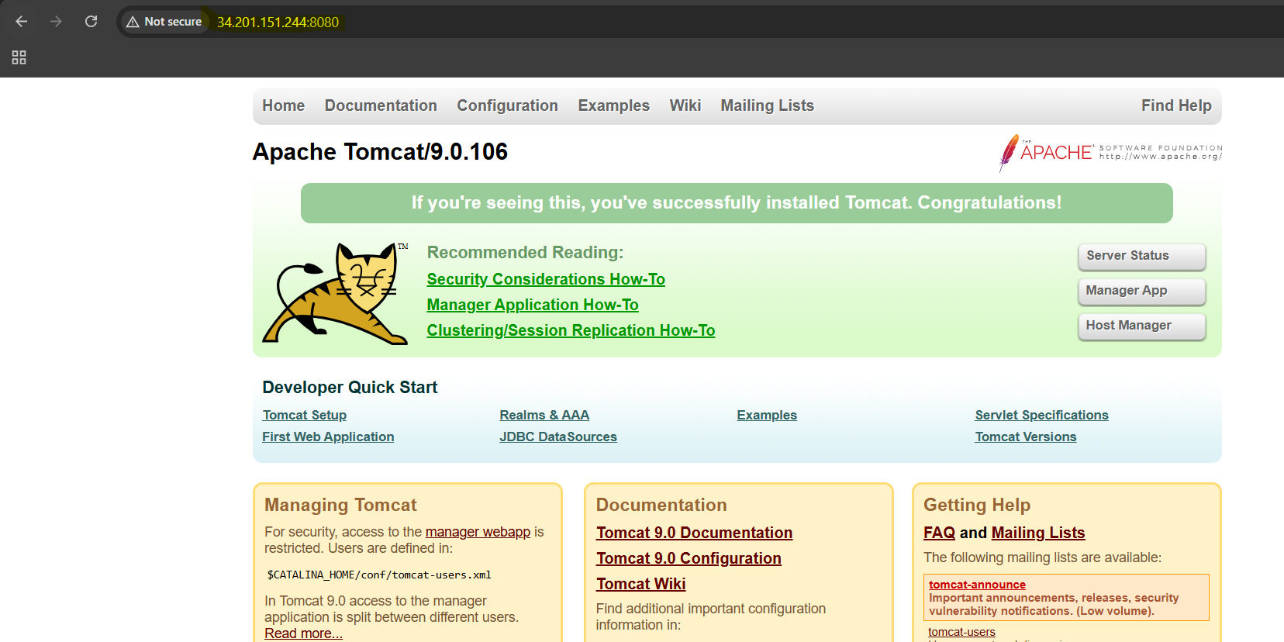

4) Write a ansible playbook to provision one ec2 on aws.

AWS credentials must be configured. Install AWS CLI and add credentials.
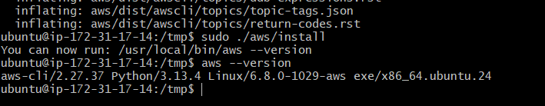
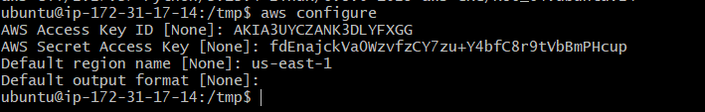
Playbook used:
---
- name: Provision an EC2 instance on AWS
hosts: all # Changed to 'all' as requested
connection: local
gather_facts: false

vars:
region: "us-east-1"
key_name: "Virginia"
instance_type: "t2.micro"
ami_id: "ami-09e6f87a47903347c"
instance_name: "Ansibletask"
security_group_name: "default"
ssh_port: 22
http_port: 80
my_public_ip: "0.0.0.0/0"

tasks:
- name: Launch EC2 instance
amazon.aws.ec2_instance:
name: "{{ instance_name }}"
key_name: "{{ key_name }}"
instance_type: "{{ instance_type }}"
image_id: "{{ ami_id }}"
region: "{{ region }}"
wait: true
count: 1
security_groups:
- "{{ security_group_name }}"
register: ec2_output

- name: Display public IP of launched instance
debug:
msg: "Instance Public IP: {{ ec2_output.instances[0].public_ip_address }}"
when: ec2_output.instances is defined and ec2_output.instances | length > 0

create a aws_ec2.yml file to enter playbook modules.
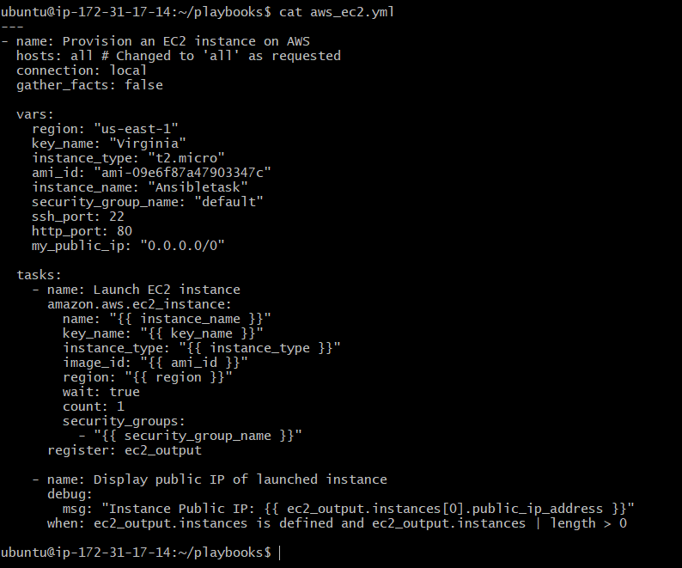

ansible-playbook aws_ec2.yml --syntax-check – To check the syntax.

ansible-playbook aws_ec2.yml – To run/execute the playbook.
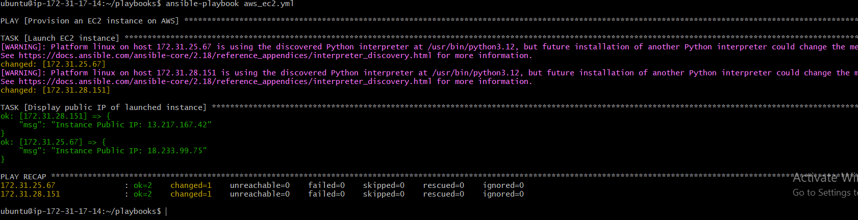

Let’s check output:
According to the output ip’s let’s check ec2’s are provisioned or not.
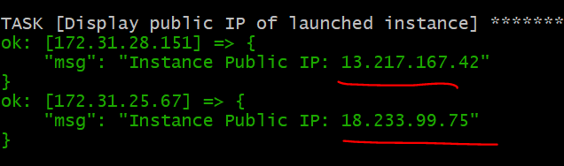
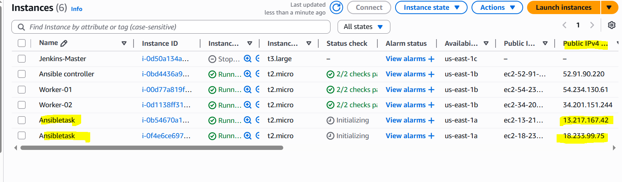

5) Write a ansible playbook to copy one file from node-1 to node-2.

Playbook:
---
- name: Copy /home/ubuntu/node1.txt from 172.31.28.151 to 172.31.25.67 via control node
hosts: all
gather_facts: false
tasks:
- name: Fetch /home/ubuntu/node1.txt from 172.31.28.151 to control node
fetch:
src: /home/ubuntu/node1.txt
dest: /tmp/
flat: yes
when: inventory_hostname == '172.31.28.151'

- name: Copy node1.txt from control node to 172.31.25.67
copy:
src: /tmp/node1.txt
dest: /home/ubuntu/node1.txt
mode: '0644'
delegate_to: 172.31.25.67
when: inventory_hostname == '172.31.28.151'

Created a node1.txt file in worker – 01
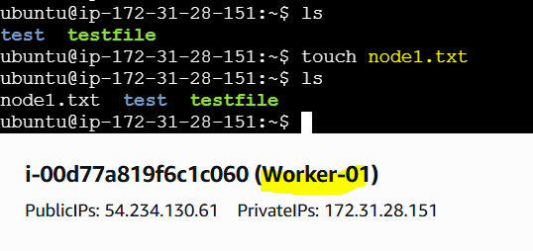

Created file copy1to2.yml playbook and added the task.
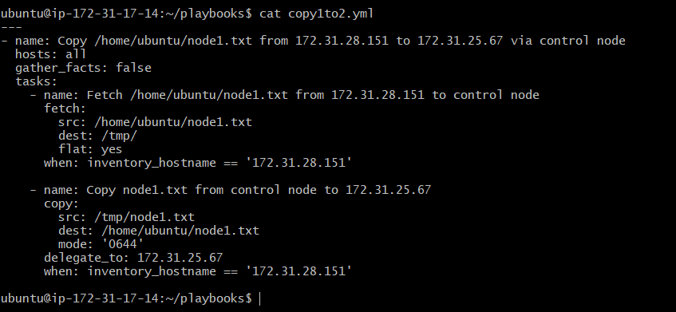

Executed the playbook, ansible-playbook copy1to2.yml

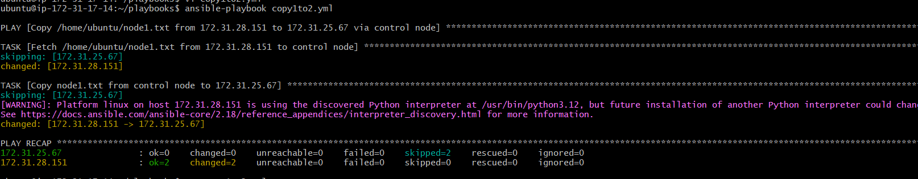

Final output on worker – 02.
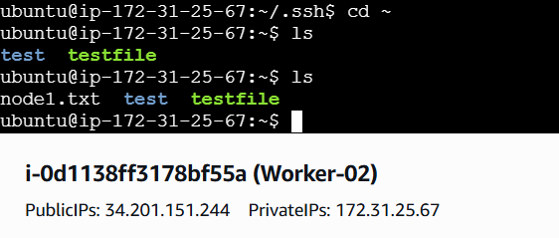

6) Write a ansible playbook to create different files with different names using single playbook.

Playbook:

---
- name: Create specific files on all nodes
hosts: all
become: true
tasks:
- name: Create multiple named files
file:
path: "/home/ubuntu/{{ item }}"
state: touch
mode: '0644'
loop:
- mubeen.txt
- syed.yml
- techie.tf
- horizon.bash

Create a playbook file with the name multiple_files.yml.
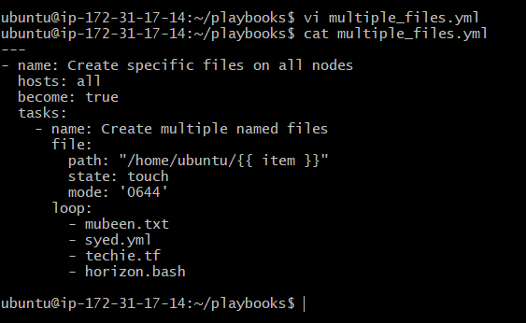

Run the playbook, ansible-playbook multiple_files.yml
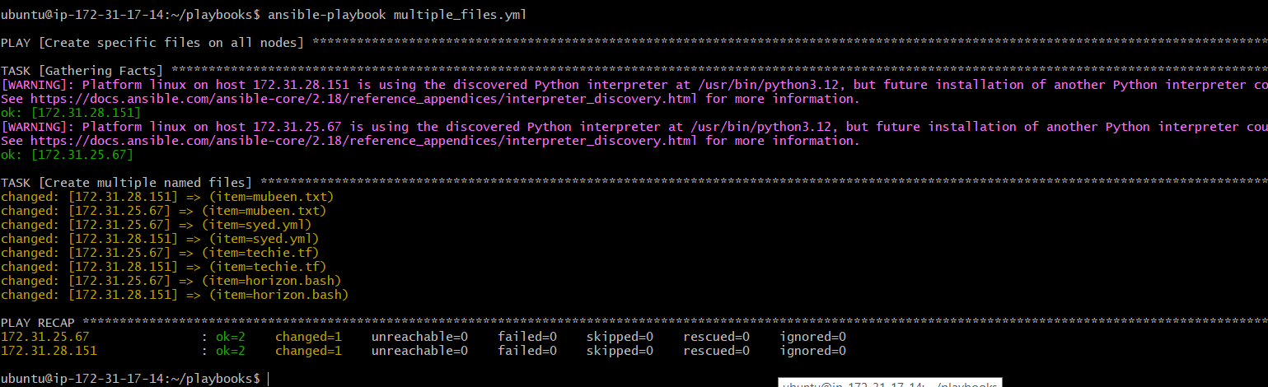

Now we can check these different files with different names in the worker servers.
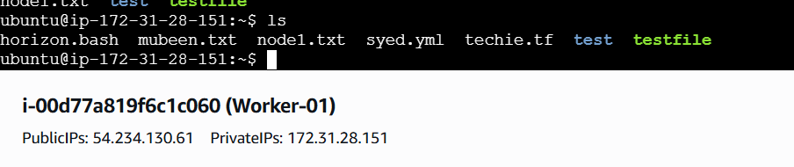
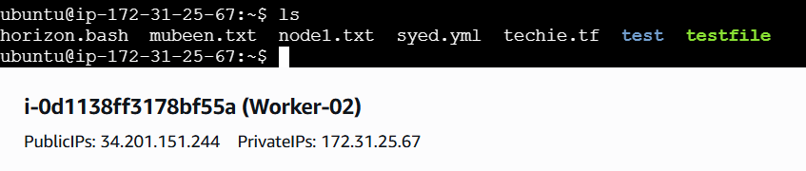

THE-END

